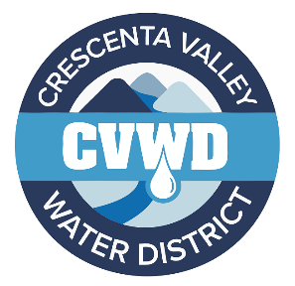
CRESCENTA VALLEY WATER DISTRICT
Teasley Avenue (2400-2500 blocks) Pipeline Replacement Project,
Project I-1116

Crescenta Valley Water District (CVWD) will be replacing approximately 1,307 linear feet of aging water pipeline as part of CVWD's FY 25/26 Capital Improvement Program. The project will replace an old 6-inch diameter water main with a new 8-inch diameter water main, install new water services, and install new fire hydrants. Below you’ll find helpful information related to this project and how you may be impacted.

CONSTRUCTION SCHEDULE:
- April 14, 2026: Saw cutting begins in 200–300-foot sections to minimize impacts to street access
- April 20, 2026: Anticipated start of water main construction
- July 6, 2026: Anticipated completion of project
Schedules are subject to change as weather and unforeseen circumstances are always a factor.

Access will be provided for emergencies, mail delivery, and trash services. Residents will have access to their properties. CVWD advises that residents avoid traveling through the construction zone whenever possible.
Two issues that the public needs to know about during construction:
- There will be a period, usually between 6 to 8 hours, when the water service to your home will be shut down. This will occur when our teams tie the new water pipeline into the existing water pipeline.
- Crews will be installing temporary parking and traffic restrictions along Teasley Ave. Temporary “No Parking" signs will be posted a minimum of two (2) days before construction. The District asks that you observe these signs and any other traffic control. Driveways within the construction zone may be temporarily restricted due to the construction. Construction crews will be on-site at 7:00am, with work beginning at 7:30am. To minimize the impact on your schedule and avoid delays, it is recommended that you utilize parking beyond the construction zone prior to 7:30am, as crews can take up to thirty (30) minutes to reposition heavy equipment and provide access out of your driveway. CVWD's on-site inspector and crew are committed to minimizing this impact and will assist you with access into and out of your driveway.

We appreciate your patience and cooperation as we work hard to provide the community with a reliable source of water for future use. Additional information will be updated periodically on CVWD's website and sent out via Everbridge.

If you have any questions or comments concerning this project, please contact:
Gabriel Gomez, Assistant Director of Operations- Phone (818) 418-9300, Email - ggomez@cvwd.com

