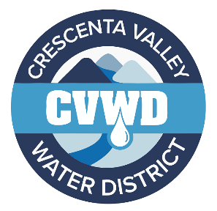
CRESCENTA VALLEY WATER DISTRICT
Fierro Circle Pipeline Replacement Project

Crescenta Valley Water District (CVWD) will be replacing approximately 160 linear feet of aging water pipeline as part of CVWD's FY 23/24 Capital Improvement Program. The project will replace an old 4-inch diameter water main with a new 6-inch diameter water main, install new water service connections, and a new fire hydrant installation. The water main was originally installed in 1961 and has outlived its usefulness. Below you’ll find helpful information related to this project and how you may be impacted.
For exact location, see the project location map below.
CONSTRUCTION SCHEDULE (March 28, 2024):
April 22, 2024- Anticipated start of construction
May 10, 2024- Estimated end of construction
Schedules are subject to change as weather and unforeseen circumstances are always a factor.
Access will be provided for emergencies, mail delivery, and trash services. Residents will have access to their properties. CVWD advises that residents avoid traveling through the construction zone whenever possible. CVWD will provide an updated construction schedule via CVWD’s website (www.cvwd.com) to better inform the residents of the construction activities as the project progresses.
As in most construction projects, this work will create a certain amount of unavoidable public inconvenience.
Two issues that the public needs to know about during construction:
- There will be a period of time, usually between 4 to 6 hours, when the water service to your home will be shut down. This will occur when the contractor ties the new water pipeline into the existing water pipeline. The District will send another letter regarding the contractor's construction schedule and the anticipated shutdown date.
- Crews will be installing temporary parking and traffic restrictions along Fierro Circle. This will allow our crews to work in a safe and expeditious manner to complete the project. Temporary “No Parking" signs will be posted a minimum of two (2) days before construction. The District asks that you observe these signs and any other traffic control. Driveways within the construction zone may be temporarily restricted due to the construction. CVWD's on-site inspector and the contractor will assist you with access into and out of your driveway.
We appreciate your patience and cooperation as we work hard to provide the community with a reliable source of water for future use. Additional information will be updated periodically on CVWD's website.
If you have any questions or comments concerning this project, please contact:
Christina Kopelman, Project Manager - Phone (818) 236-4115 or by
email - ckopelman@cvwd.com

